Welcome to Busy Beans Nursery
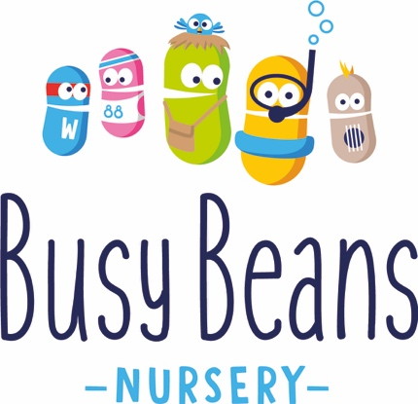

CHILD ENTRY FORM
“Empowering Children to Achieve More”

Please complete all the necessary information below (if applicable) to secure your child’s place at Busy Beans Nursery.
Child’s Details | Date of birth:
First Name: | Surname:

Mother’s name:
Home number:

Work number:

Mobile number:

Email address:

Home address:

Work address:

Father’s name:

Home number: (If different from above)

Work number:

Mobile number:

Email address:

Home address: (If different from above)

Work address:

Toilet trained: yes / no
Any words / gestures to indicate needing the toilet:
Any sensitivities e.g. sound:

Any likes & dislikes:

Name and age of siblings:

Child’s first language:

First language of parents:

Language spoken at home:

Has your child had any previous child care arrangements: | Details
Does your child enjoy any particular play activities:

Does your child have a sleep routine: | Details
Does your child have a comforter item / toy: | Details

Your child’s start date:

Your child’s Keyworker will be:

SESSIONS REQUIRED:
FULL DAY SESSION  7:30am – 6:00pm  (10.5HRS) | FLEXI SESSION  7.30am – 3.00pm  (7.5hrs) | SHORT MORNING SESSION  7:30am – 1:00pm (5.5hrs) | AFTERNOON SESSION  1:00pm – 6:00pm  (5hrs)

Monday | Tuesday | Wednesday | Thursday | Friday

TERMS & CONDITIONS

I have enclosed a non-refundable deposit for £200.00. The fee covers administration costs and the introductory sessions my child will have prior to their start date.
This deposit will secure my child’s place at Busy Beans Nursery.
Deposit for siblings £100.00.
The nursery is open between 7:30am-6:00pm, Monday to Friday. We are open 51 weeks a year, excluding a week over Christmas and we are closed on Bank Holidays and fees are payable at the times of closure.
Please refer to your contract and Parents Handbook as part of your contractual agreement.

Notification of payments
Deposit paid (circle one): | Yes No
Date received:

Payment method (circle one): | Cheque Cash Bacs
Name of person on payment option:

NB: Please ensure you complete the name of person to make payment to avoid any invoice errors
Our bank account details are as follows.
Busy Beans Nursery account number 27069583 and sort code 60 - 12 - 03.
Payments should be made within 5 working days of the billing dates provided for each month.
. Please make the payment referenced with your child’s name and payroll number

Please do not hesitate to contact the Management Team if you would like to discuss anything further
Address:
Busy Beans Nursery
Victoria House
Victoria Avenue
St Lawrence
JE3 1LU
Telephone: 01534 630036
Email: manager@busybeansnursery.com

